- Define GESTATION and tell me the lengths of time gestation occurs in Cattle, Swine, Sheep, Horses, and Goats, the average days and range of days. (15 pts)

2) We talked about Estrus Cycle. Because this is a take home test, I can expect you to look for a diagram or explanation of what hormones are involved, where they are developed or released, and when each hormone is released. Read the article on Estrous Cycle on snyderrick.weebly.com and explain how the hormones interact to make cows come into heat. (20 pts)

3) Explain each of the following and why each is practiced on farms: (10 pts) Info both in the Holstein pamphlet we used in class and the Learning About Dairy Booklet on my Weebly page.
a) Linebreeding/ Inbreeding

b) Outcrossing

c) Crossbreeding

4) What are the signs of estrus for dairy cattle? (10) (bonus 2 points, sign of estrus in a sow?)

5) What is Embryo Transfer, and what reasons might a farmer use this tool? (5) (Holstein and Learning About Dairy)

6) What is In Vitro Fertilization, and why would a farmer utilize this technique? (5)

7) Read the article on Genomics on the snyderrick.weebly.com site. How would you describe the process of Genomic testing? What advantages does genomic testing provide to dairy farmers? Would you use genomic testing if you were to start your own herd of cows? Looking at the chart of 5 animals from the University of Wisconsin’s Integrated Dairy Herd, which animal would you buy if you had to choose one? Why? (20 pts)

8) Define Parturition, what is it called in cattle? in swine? in horses? in sheep? (10 pts)

9) Tell me what the signs of Parturition are for Dairy Cattle? (5 pts)

Extra Credit (8 points)

Explain in your own words
Genetic Variance:

Accuracy of Selection:

Selection Intensity:

Generational Interval:

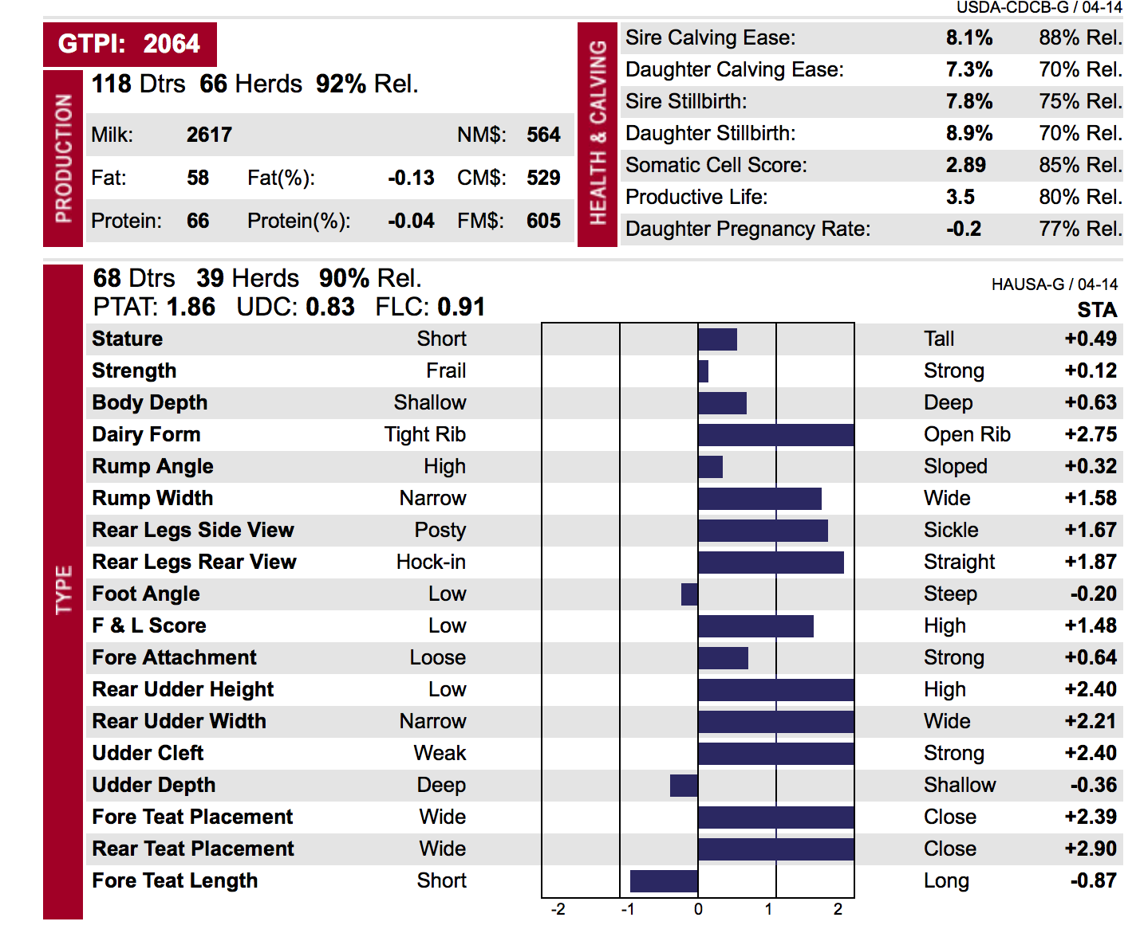
Extra Credit 2 (10 pts.)

- Which Bull will produce taller cows?

B) Which bull’s daughters will milk more?

C) Which Bull’s daughters will have fewer difficult births?

D) Which bull’s daughters will breed easier?

E) Which bull has more daughters?

F) Which bull should have the most desirable show ring daughters?

G) If I want to improve my herd’s udders, which bull Bull A ^ Bull B v should I use more often?
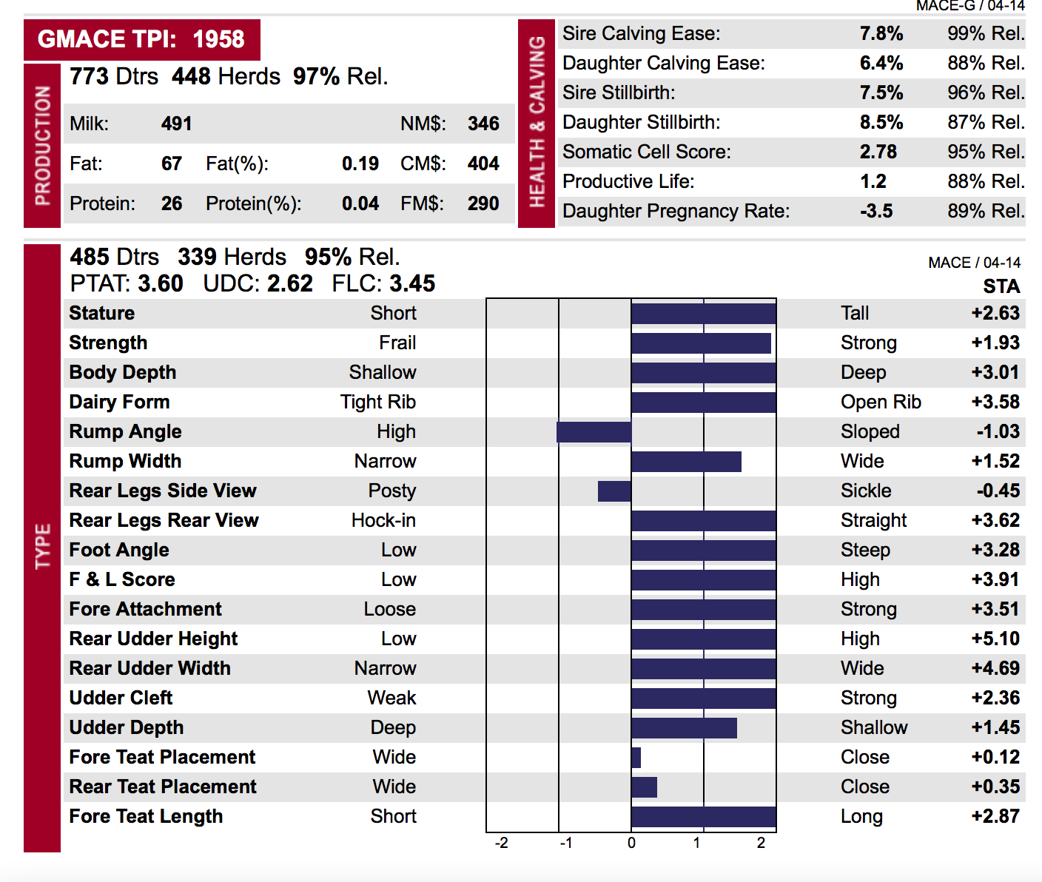
H) If I want to improve my herd’s pounds of fat shipped, which bull should I use more often?

- What does GMACE TPI mean on Bull B’s info? (especially the MACE part)?

J) Which bull provides more pounds of protein from his daughters?

